Friday pack

Kofi Gye Nyame Mug
https://www.amazon.com/dp/B0H59VLGGH
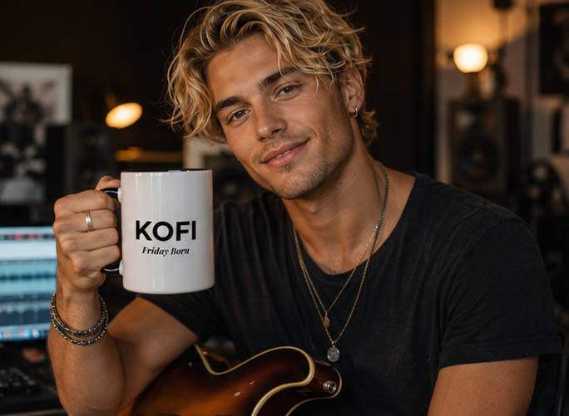
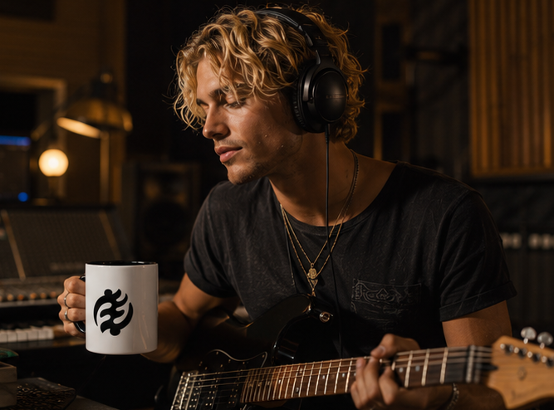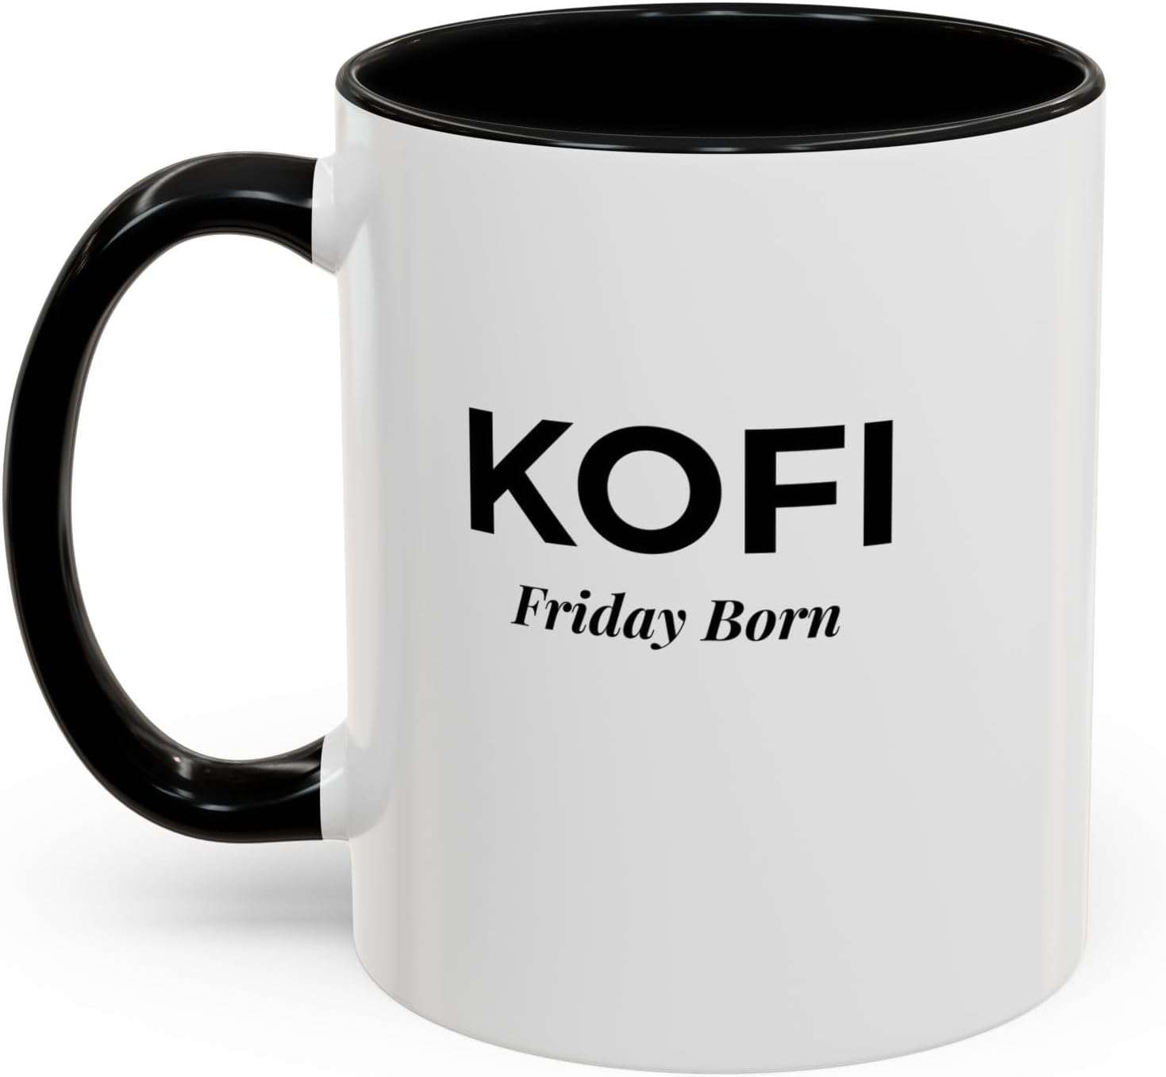

Kofi Sankofa Mug
https://www.amazon.com/dp/B0H5B667J5
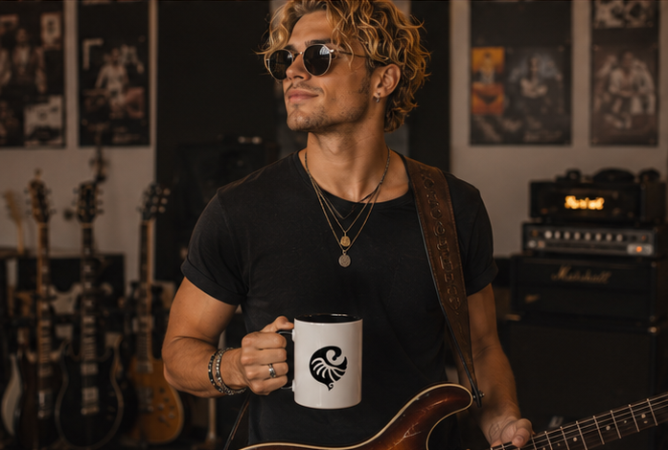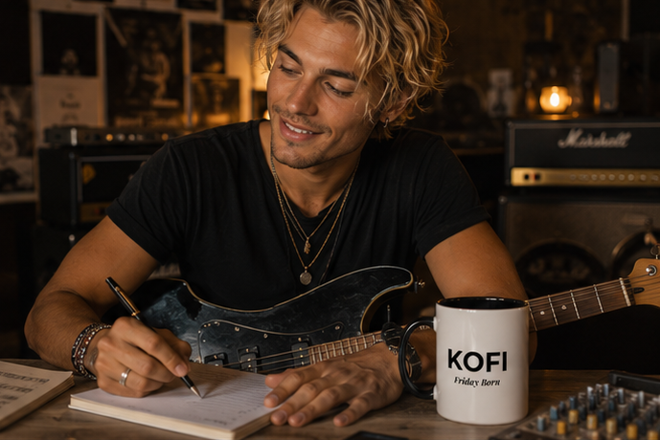

Afia Gye Nyame Mug Amazon
https://www.amazon.com/dp/B0H59ZS41J

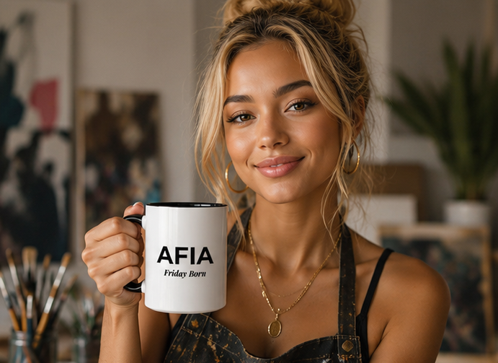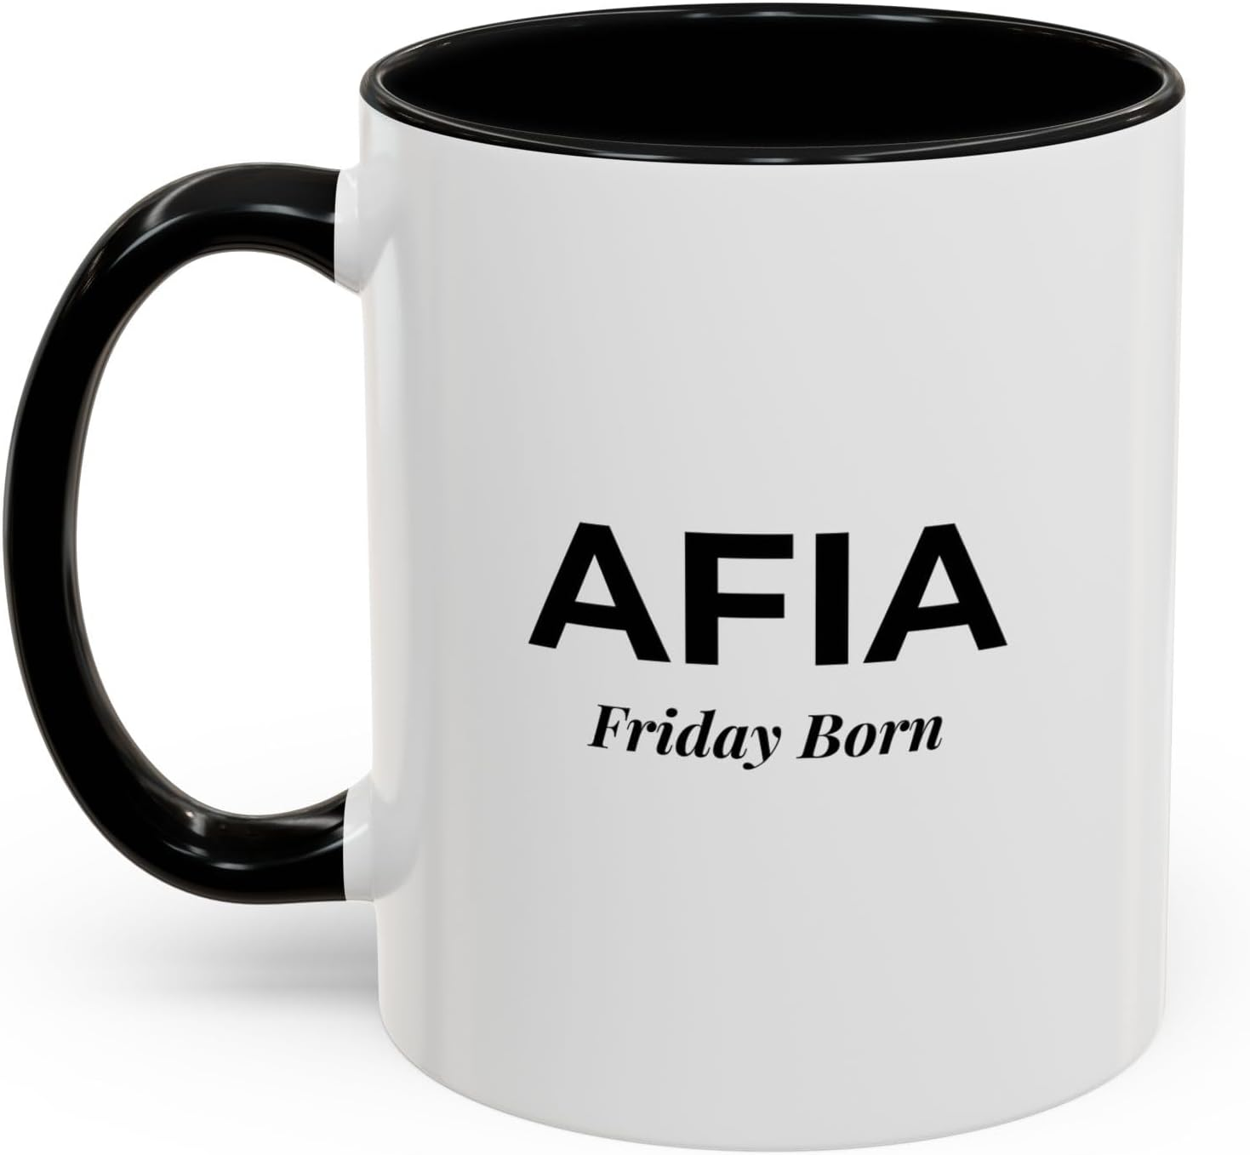
Afia Sankofa Mug Amazon
https://www.amazon.com/dp/B0H59RFLQ9

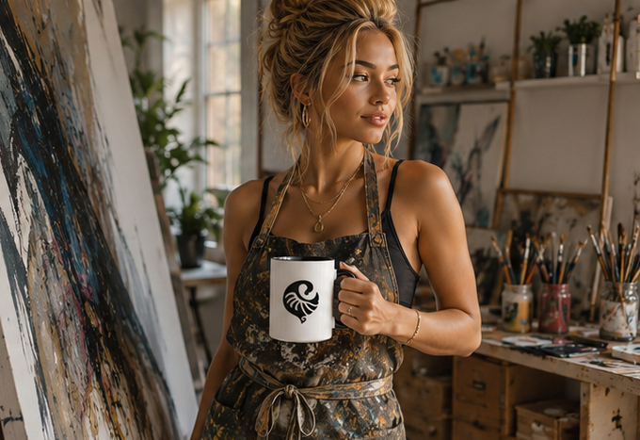
Afia infant onesie
https://www.amazon.com/dp/B0H5BW8H5F?th=1&psc=1
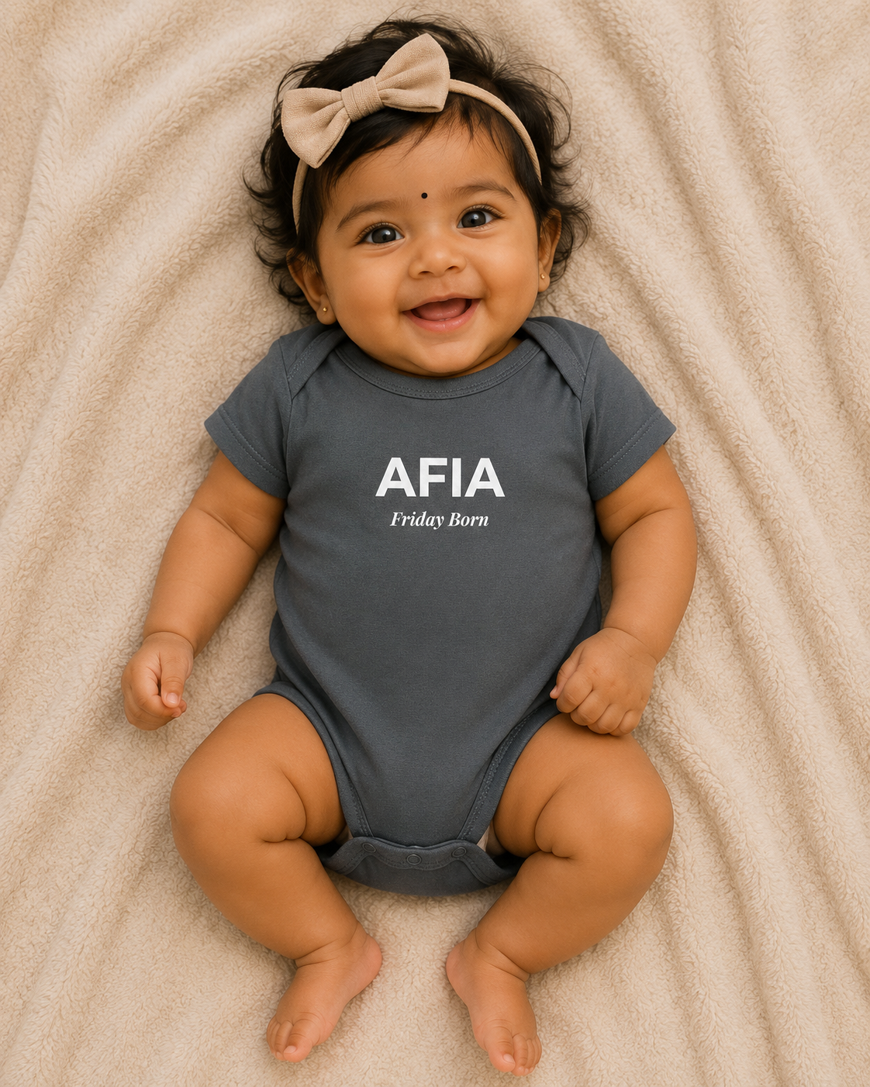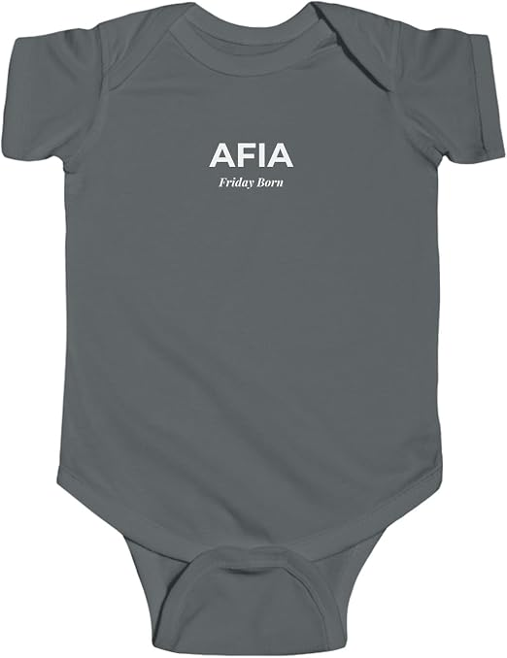
Kofi infant onesie
https://www.amazon.com/dp/B0H5BSYK74?th=1&psc=1
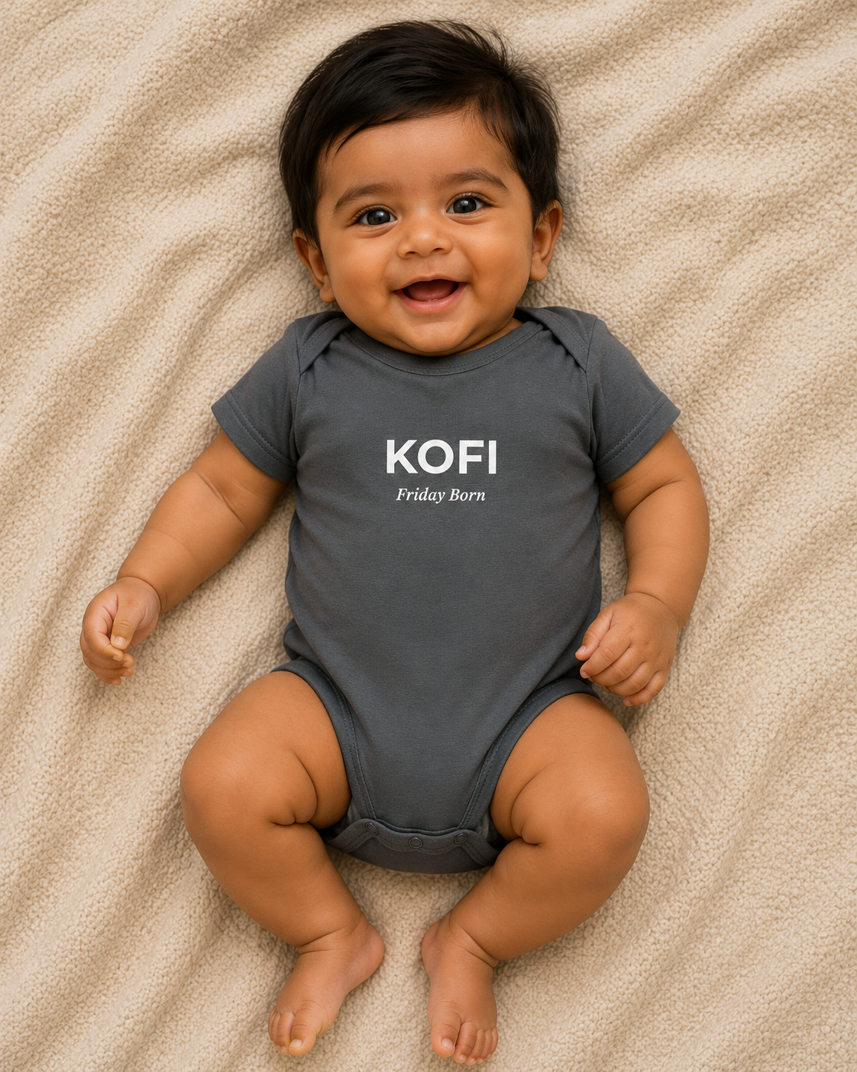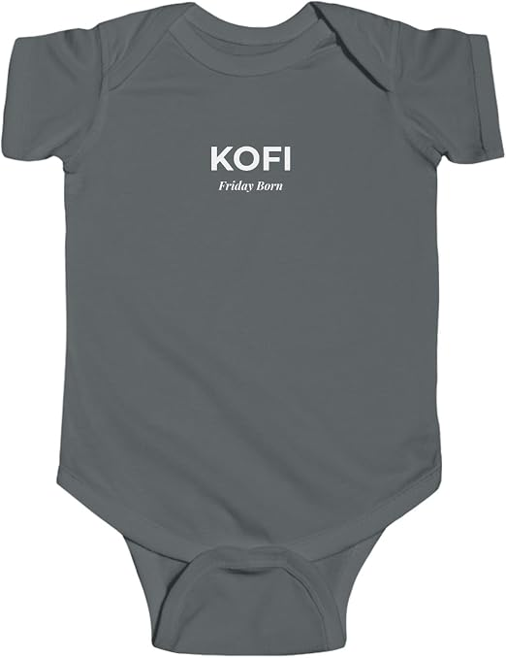
Afia Sankofa shirt
https://www.amazon.com/dp/B0H58XWNNX?th=1&psc=1
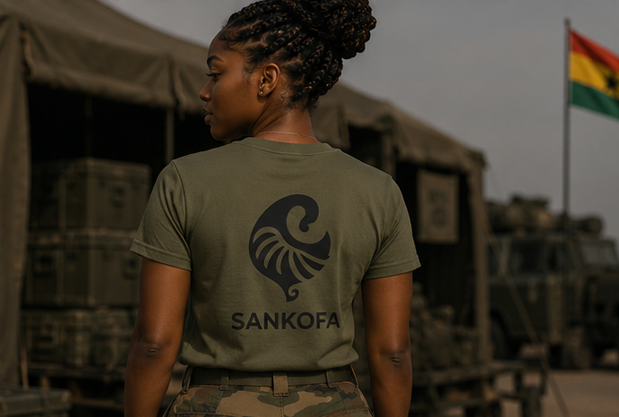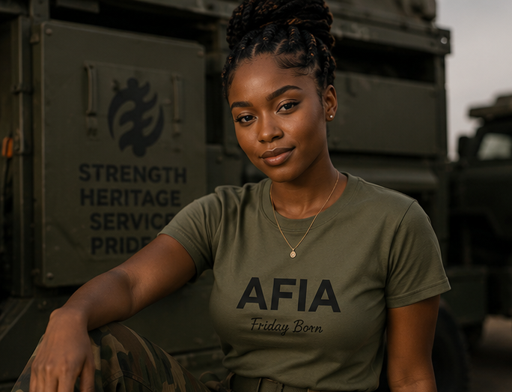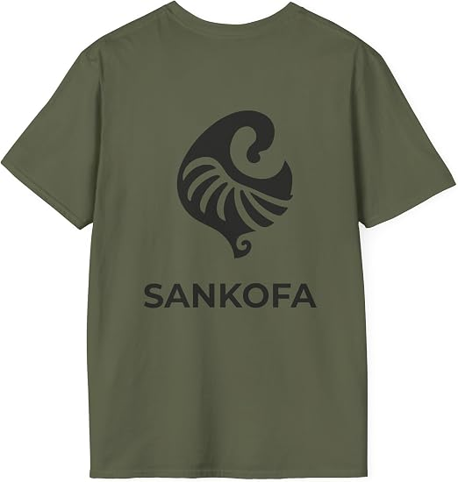
Afia Gye Nyame Shirt
https://www.amazon.com/dp/B0H58RFZ49?th=1&psc=1
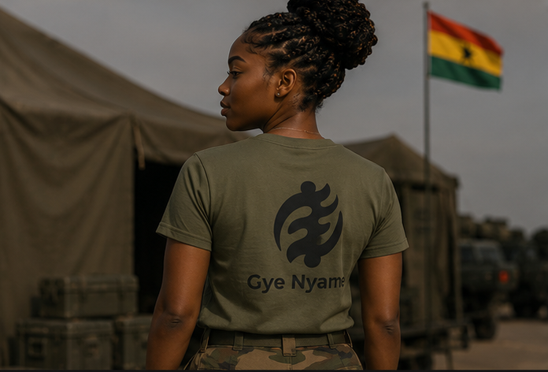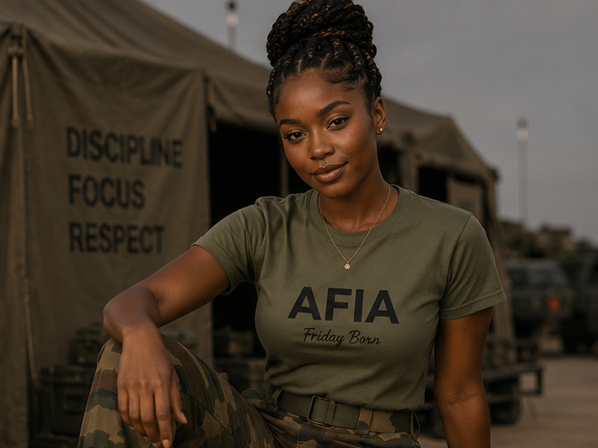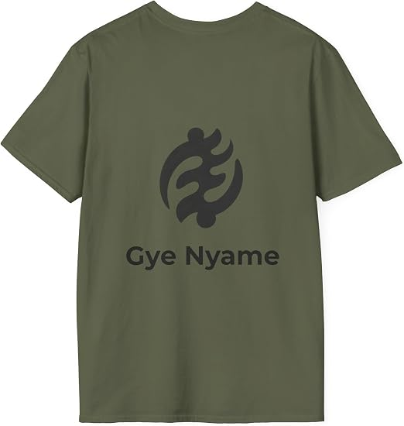
Kofi Sankofa shirt
https://www.amazon.com/dp/B0H58W8X8W?th=1&psc=1

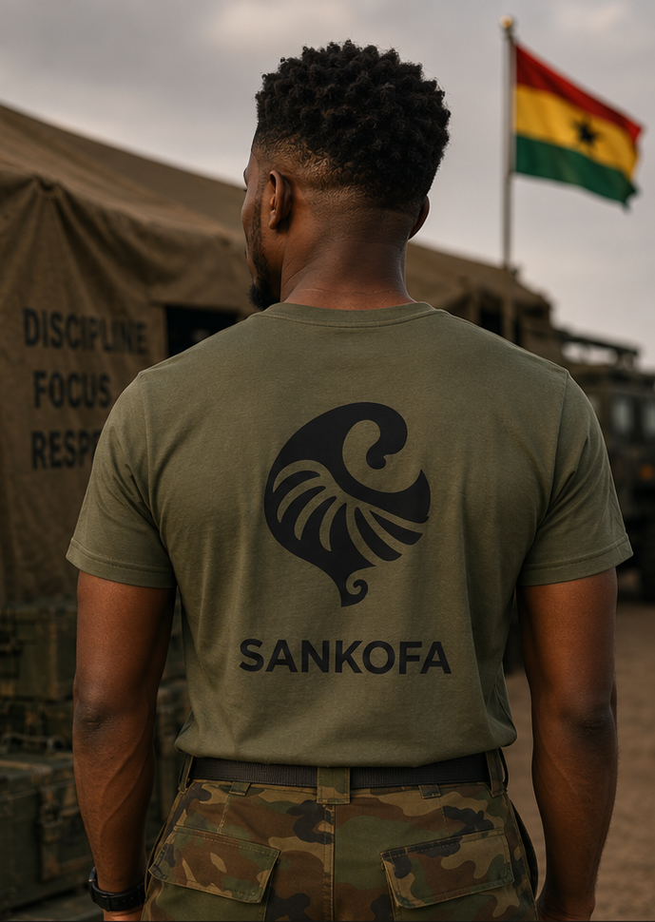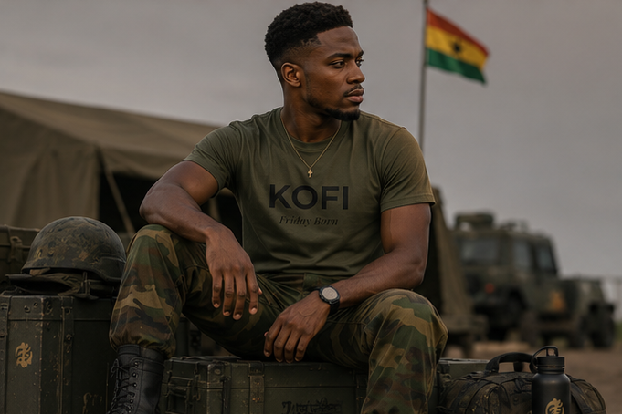
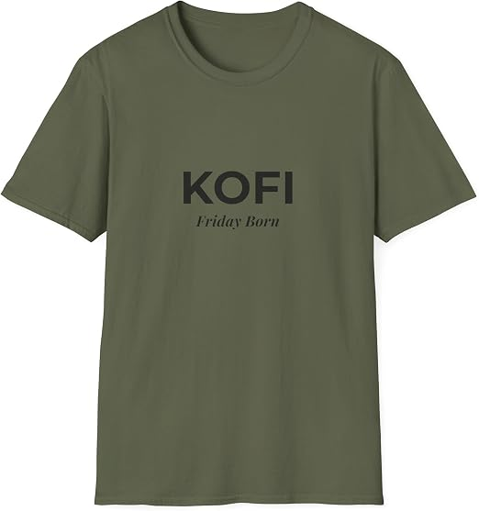
Kofi Gye Nyame Shirt
https://www.amazon.com/dp/B0H58T4FGX?th=1&psc=1

